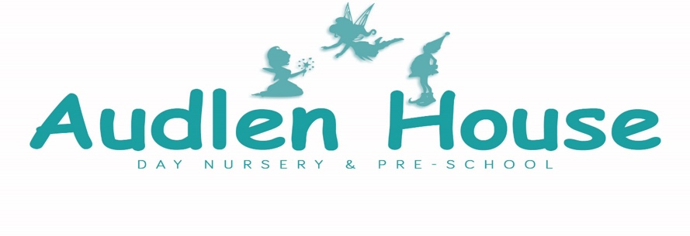

Curriculum Statement: Intent, Implementation and Impact
Intent – At Audlen House Day Nursery, we intend for our curriculum to invite, support and enhance a child’s curiosity, confidence and competency to flourish as an individual.
By providing a well-structured learning environment, we aim to encourage independent, enthusiastic learners who can thrive and reach their full potential. We recognise that to best achieve this, working together with parents and carers is important. Irrespective of individual backgrounds, circumstances or needs, it is our intent that all babies and children who attend Audlen House Day Nursery, continue their learning journey by further developing physical skills, communication & language, social and emotional skills, all whilst embedding a positive attitude facilitated through play-based learning. Our intent at Audlen House Day Nursery is to enable the babies and children we care for to:
- Feel safe and secure. This enables them to form strong attachments and relationships with adults and children so that they enjoy coming to nursery.
- Become confident, competent and creative learners who are curious about the world around them and keen to learn new skills and knowledge.
- Become skilful communicators; enabling them to connect with children and adults through language and play, ensuring that they are immersed in a vocabulary rich environment.

Implementation – At Audlen House Day Nursery, our curriculum intentions will be implemented by following the Early Years Foundation Stage Framework (2021). This is made up of the overriding principles of the Unique Child, Positive Relationships, Enabling Environments and Learning and Development.
- Unique Child – Every child is a unique child who is constantly learning and can be resilient, capable, confident and self-assured.
- Positive Relationships – Children learn to be strong and independent through positive relationships.
- Enabling Environments – Children learn and develop well in enabling environments, in which their experiences respond to their individual needs and there is a strong partnership between practitioners and parents and carers.
- Learning and Development – Children develop and learn in different ways.
The framework covers the education and care of all children in early year’s provision, including children with special educational needs and disabilities.
The implementation of these principles comes from a play-based learning environment as part of our child initiated continuous provision combined with adult supported or initiated play opportunities which ensure that babies and children master basic skills and make progress. All babies and children will be provided with opportunities to access outdoor provision daily.
The learning experiences within our nursery are linked to the seven areas of learning and development within the EYFS (2021). These areas are split into three prime areas and four specific areas. The three prime areas are those which the children should develop first and are considered most essential for the healthy development and future learning of our babies and children. These include:
- Physical Development – involves providing opportunities for babies and children to be active and interactive and to develop their co-ordination, control, and movement. Babies and children will also be helped to understand the importance of physical activity, dental hygiene and to make healthy choices in relation to food.
- Communication and Language – involves giving babies and children opportunities to experience a language rich environment, to develop their confidence and skills in expressing themselves and to speak and listen individually, in small groups and larger groups with adults and children.
- Personal, Social and Emotional – involves helping the babies and children to develop a positive sense of themselves, and others, to form attachments, positive relationships and develop respect for others, to develop social skills and learn how to manage their feelings and to have confidence in their own abilities and resolve conflicts peacefully.
As children grow and make progress in the prime areas, this will help them to naturally develop skills within the four specific areas. These are:
- Literacy – the importance of developing a lifelong love of reading. Reading consists of two dimensions Language Comprehension and word reading. Adults will talk with the babies and children about the world around them, read fiction and non-fiction stories with them, and enjoy rhymes, poems and songs together.
- Mathematics – the early teaching of mathematics involves providing children with opportunities to develop and improve their skills in counting, understanding and using numbers, describing shapes, spaces, and measures. Looking for patterns and relationships, spotting connections and having the confidence to 'Have a Go'.
- Understanding the World – this involves guiding babies and children to make sense of their physical world and their community through opportunities to explore, observe and find out about people, places, technology and the environment.
- Expressive Arts and Design – this involves enabling children to explore and play with a wide range of media and materials, as well as providing opportunities and encouragement for sharing their thoughts, ideas and feelings through a variety of activities in art, music, movement, dance, role-play, and design and technology to develop their artistic and cultural awareness.
Babies and children benefit from meaningful learning across the curriculum so staff will plan resourcefully for opportunities for communication, Sustained Shared Thinking and physical challenge to build on existing skills whilst also considering the Characteristics of Effective Learning.
We will implement rich first-hand opportunities to broaden lived experiences, awe and wonderment. We will encourage exploratory learning and thinking creatively including problem solving across all areas of learning. In addition, we will support new vocabulary and concepts through reading which will excite and engage all learners which includes staff modelling standard English and asking high-quality, open-ended questions.

Impact – At Audlen House Day Nursery, the impact of our curriculum will enable the babies and children we care for to be well prepared for their future.
When a child starts at Audlen House Day Nursery, we will gather a baseline assessment of the baby or child’s starting points, with support from the parents or carers, and then make informal, practitioner-based, assessments through careful observations to inform planning for next steps. We will carry out regular internal moderation discussions as a team and promote CPD to enable the staff to feel confident with our practice and assessments and by extension, the impact of our curriculum. By monitoring assessment procedures regularly, we will be able to effectively demonstrate what learning is taking place and how each child is progressing in all seven areas of the EYFS (2021) supported curriculum.
The impact of the learning opportunities we provide will be shared with parents and carers who will also have an input. Using the Tapestry Learning Journal System, we can share the babies and children’s play and learning with their parents or carers and encourage feedback and dialogue surrounding this. Effective communication and collaboration ensure that the children will leave Audlen House Day Nursery with a solid foundation of learning on which to continue to build upon.
The babies and children we care for will be well prepared for their future. This is both shorter term, such as experiencing smooth transitions between groups, other settings or school, to longer term such as becoming lifelong learners and positive members of the community in which they live.

